GOOGLE DRIVE INSTALL IN WINDOWS

On your computer, go to https://support.google.com/a/users/answer/9965580?hl=en
this link follow the installation instructions to download and install Drive for desktop.

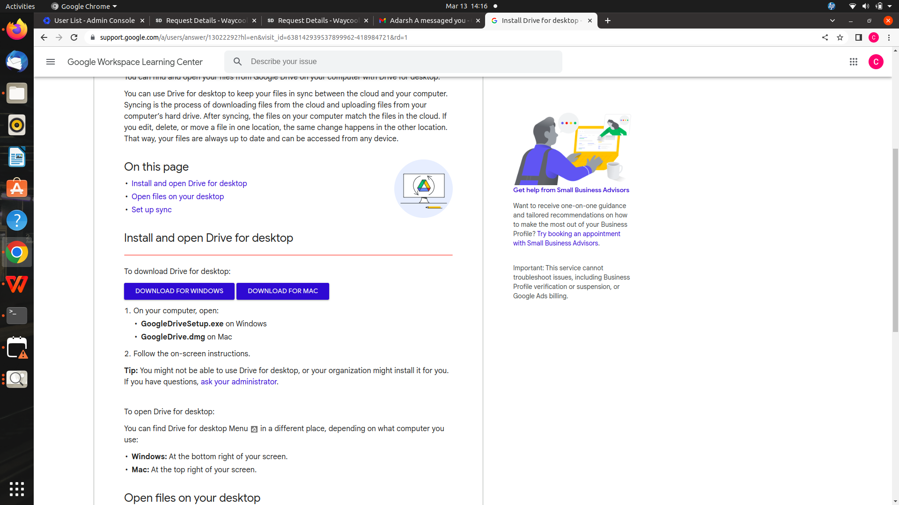

After installation login your email. then G drive sync in your deskto
